**HSS 232 HOSPITAL VISIT**

Group: 11

ANKIT SINGH 2201AI47

DEEPANSHI VERMA 2201CS85

SRIYASH BHASKARUNI 2201CS69

RAVINA BUDANIA 2201CS81

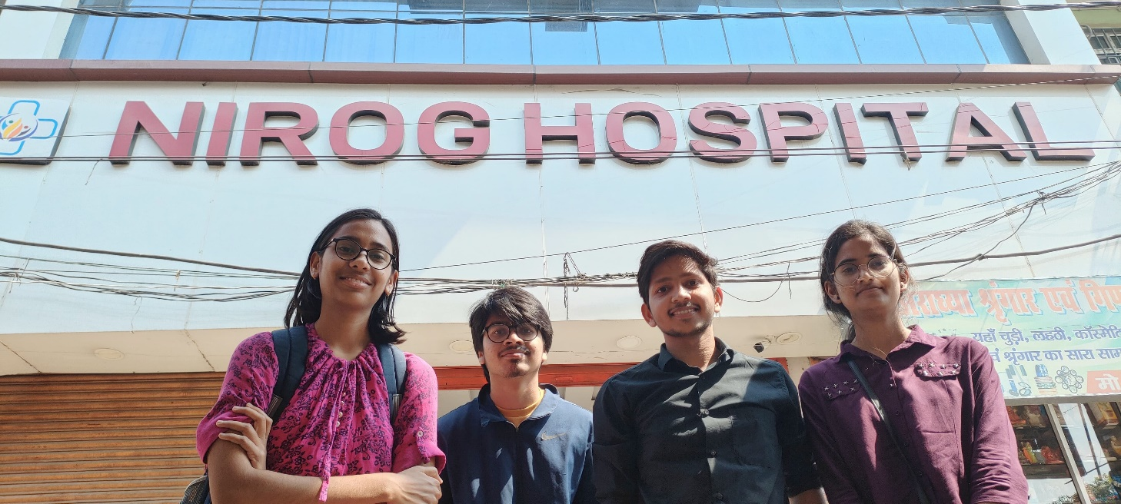

ABOUT THE HOSPITAL: THE WHERE? AND THE WHAT? :

Address : Standing up at Pillar No.77 at Sheikhpura, Bailey Road, Patna, Nirog Hospital is well known for its high regard of patients through bringing up various services accessible to patients whenever needed.

A private hospital providing round-the-clock services, it offers outpatient services in specialties like Neurology, Internal Medicine, Gynaecology, Oncology, Paediatrics, Cardiology, Orthopaedics, Psychology, Nutrition and dietetics. This would guarantee that people have the required specialized care they need as well as the medical conditions that target the who to the wide.

Guided by the good doctors, nurses, and medical staff the hospital possesses from latest facilities and state-of-the-art medical technology. Hospital’s bed count stands at 51, which includes 12 ICU beds, thus giving emergency patients the close attention and medical care they deserve. Having 4 operation rooms, the hospital is equipped with an oxygen supply and can respond accordingly and fast to emergencies and surgical procedures with a high degree of efficiency.

Nirog Hospital puts emphasis on patient satisfaction and convenience by meeting their requirements. The dedicated hospital departments in which patient care are handled by specialized healthcare staff ensure that there is no reason the patient might worry that the staff is not qualified to handle the case. The hospital also includes an on-site pharmacy providing the convenience to patients relying on both inpatient and outpatient pharmacy services.

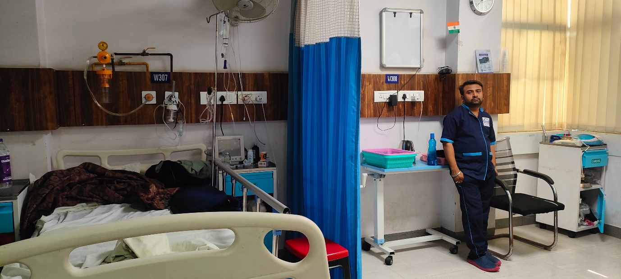

The hospital accommodates the rehabilitation building where the patients can undergo rehabilitation service that helps recovery. Besides this, it has maternity and paediatric units constructed in a way that mothers and children benefit from specialized treatment needed for women who are pregnant and for children.

Nirog Hospital API is equipped with telemedicine, whereby patients receive consultations and advice from their own homes with the use of technology. Moreover, it engages health workers in hospital settings and community settings, helping the patients to have regular checkups aimed at maintaining their health and wellbeing. It is true that the hospital is not provided with its own blood bank but the relationship with the other reputable institutions like Paras, Palmview, Prathima and Nirmaya is always sustained in case there is a need for blood transfusion.

In three lines the Nirog hospital could be summed up as an outstanding centre for healthcare and a collection of varied medical services that meets the requirements of patients. Not leaving any stone unturned such an institution carries out its mandate to offer standard of care as well as great infrastructure to behave as a conditioned medical services institution in Patna.

Despite such wonderful facilities available in the hospital, we found some disparity when we compared the actual data that we collected to that available on the website. Some are shown in the table below.

|  |  |
| --- | --- |
| QUOTED DATA | ACTUAL DATA |
| * Number of doctors: 120+ . | * Number of doctors: 20 . |
| * Minimum qualifications of doctors present: Most of them being M.D and some of them with M.S . | * Minimum qualifications of doctors present: M.D . |
| * Number of employees : 150+(including guards , nurses, cleaning staff) . | * The total number of employees : 56 (This includes 25 nurses,25 cleaning staff,6 guards based on the shift). |

The table above shows that there is a huge disparity between the details shown in the website and that collected upon arrival. The number of doctors presented upon arrival is 20 as compared to 120+ as stated on the website.

A similar disparity in the working staff data was also observed wherein the quoted was 150+ staff while only 56 staff were known to be present upon arrival. We also found that the doctors on call were only “M.D doctors” as opposed to a few of them also having an “M.S”.

Here are the details of a few of the doctors present in the hospital:

While there are definitely many good things about this establishment, no establishment can be perfect and there are definite down sides of the hospital as given below are a few pros and cons about Nirog hospital.

|  |  |
| --- | --- |
| PROS | CONS |
| * Clean environment. | * The lack of a navigation map made it difficult for us to track the whereabouts of the general and ICU wards. |
| * An Inhouse pharmacy and canteen. | * There were no separate washrooms. |
| * A supportive hospital staff | * The waiting area of the hospital is still under construction. |
| * CCTV cameras were also present |  |

The hospital comes across as a hygienic and convenient place for the patients with the presence of an inhouse canteen and pharmacy if it wasn’t for the lack of a proper waiting area which is still under construction. Given the recent establishment of the hospital it is understandable if there are certain unfinished areas but lacking a waiting room makes it hard for the people who are there for the support of the patient and it is definitely something they should be constructing as soon as possible. The patients do have a supportive staff catering to their needs and the places very much secured with presence of CCTV cameras. One shocking discovery was made in reception area of the hospital where we found no separate washrooms for different genders! In a generation where certain places have different washrooms for male, female and even transgenders, it was shocking to see the lack of separate washrooms even for male and female!

SURVEY ANALYSIS: THE EXPERIENCE: -

It is difficult to find a hospital where all of the admitted patients were satisfied with the services of a hospital. Even the big and reputed hospitals often have a few unsatisfied patients due to various reasons. Some of the more common issues faced by people of such hospitals are the extended wait times and high cost for services. It was astonishing to not only see that all the patients we have come across were satisfied by the service provided but there was little to no wait time and on top of that the patients/customers who were not extremely satisfied (They were only satisfied) only did so as they felt the cost could have been a little lowered.

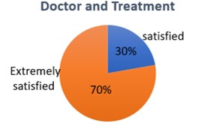These are a few graphs made based on the data collected during survey.

This pie chart is based on how the patients felt about the doctors and treatment and to our amazement all were satisfied.

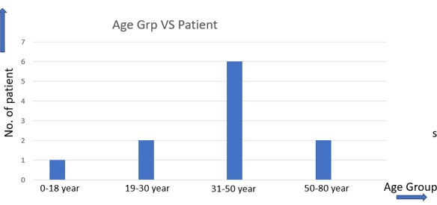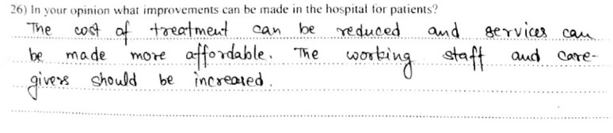

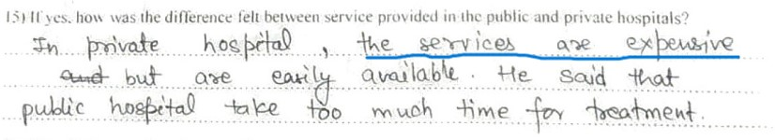

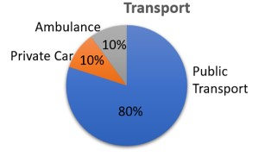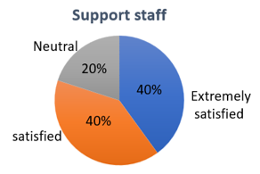

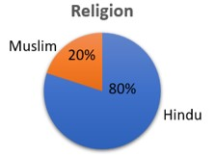Most of the staff were also satisfied with the work environment.

The other graphs show data like distribution based on religion, based on mode of transport and an age distribution.

As we can see most of the patients are middle aged and belong to the age group 31-50.

The availability of payment through card and digital payment is also something that makes the services easier to use for the patients.

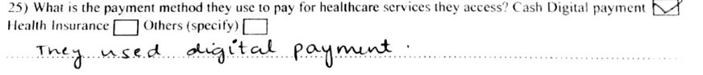The one thing that patients did mention as the reason for them giving such good ratings is the lack of wait time and along with that is the cleanliness in the hospital premises.

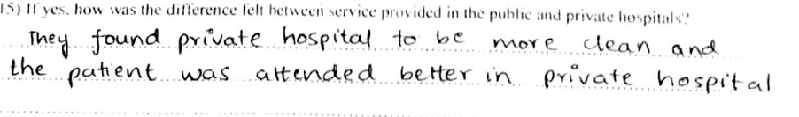

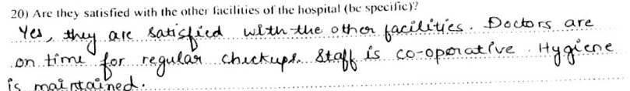

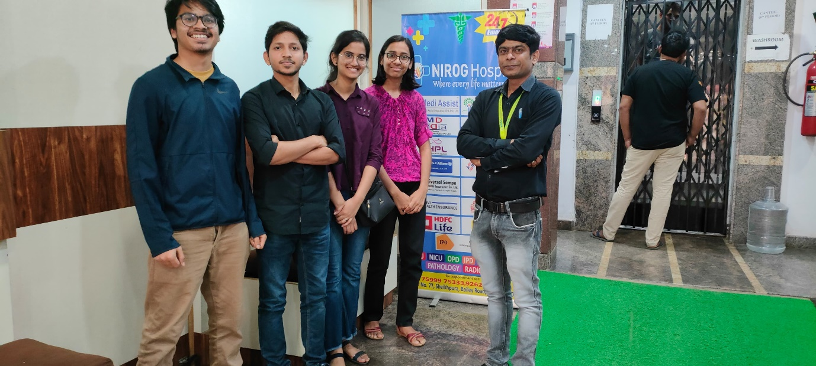

**THE PROBLEM: THE WHY? :-**

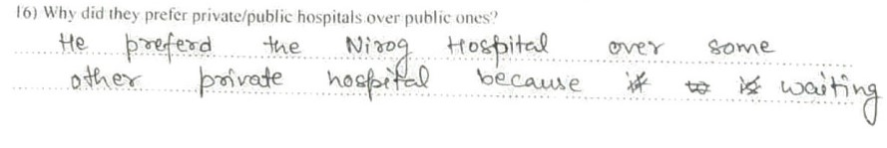With people not being dissatisfied with the services provided in hospital one might say that there is no problem at all. The problem lies with why the patients are here in the first place. Upon surveying the patients, we discovered that prior to visiting Nirog hospital they were undergoing treatment elsewhere and turns out Nirog was never their first choice for treatment! These patients were here either because they were recommended or due to the dreaded waiting times they had to endure during their treatment in these other hospitals. This was the case with most of the patients regardless of whether they were treated in a private or a public hospital.



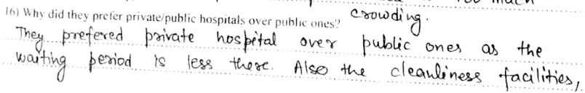



**SOLUTION PROPOSED: -**

PART 1:-

* **WHAT IS THE SOLUTION ?**

The solution is a city wide QR-Web based platform called **SAHAYAK**.

* **HOW DOES IT WORK?**

It will show the live number of patients (including those people who have online booking) waiting in a particular hospital to visit a particular doctor of a particular department for e.g. Nephrology. It will also display the number of beds that are unoccupied in the hospital. QR codes with helpline numbers will be circulated within the city.

* **HOW WILL THE QR BE CIRCULATED**

This can be done with the help of brochures, posters and medicine wrappers and this way they can reach the rural areas too. Shown below is the website.

* **HELPLINE NUMBER**

The most important part of society when we address a health care issue are those who are aged or elderly people who can’t use a smart phone or are economically weak and do not own a smart phone. They can use this helpline number which uses IVR (INTERACTIVE VOICE RESPONSE) in four levels. This IVR system will be connected to the SAHAYAK database and thus will give appropriate results.

LEVEL 1: CHOOSE THE AREA (FOR EX. BAILEY ROAD)

LEVEL2: CHOOSE THE HOSPITAL.

LEVEL3: CHOOSE THE DEPARTMENT

LEVEL4: CHOOSE THE DOCTOR

After passing these four levels you can get the exact number of people who have taken receipts for regular checkups for the same doctor at that particular moment. In this way before leaving the home for a regular checkup you already know where to go for smooth experience of a regular checkup or a visit.

**WHO WILL UPDATE SAHAAYAK?**

Hospital staff preferably reception counter will update the number of patients and unoccupied beds.

**SOLUTION PART 2:-**

* **WHAT IS IT?**

The solution to the problem is **VIRTUAL SWASTHYA KHAATA**.

* **HOW DOES IT WORK?**

When we will visit the doctor for the first time, he/she will give us a SCRATCH CARD that will be similar to the talk time card we had in previous times to recharge our mobile phone. On scratching the card, we will have a code when we will enter the code the VIRTUAL SWASTHYA KHAATA will be updated by a talk time of 5 min. The card will have a validity so that it can be used for follow-ups only.

* WHY WILL SOMEONE PREFER THIS WAY?

1.No cost follow-ups.

2.It is convenient.

3.Any one with a phone can use this whether it is a smartphone or a phone with keypad.

* **CHANGES AT THE DOCTOR’S END**

We will modify the prescription of the doctor with a mobile number and a virtual room link. He/she will connect to the patients (FREE OF COST) who just need a follow up on their treatment and do not have a need of physically visiting again using this mobile number or the link.

There will be a fixed hour for each doctor when they will attend these audio chats and video chats with their current patients for the smooth functioning of the system.

If still a patient feels there is a need to visit the doctor again, they can physically come and again pay the fees and visit the doctor again. This way we can decrease the number of patients physically meeting the doctor and reduce the overcrowd in the hospitals.

* **IS THIS FEASIBLE AND CAN IT BE IMPLEMENTED?**

Average consultation time in India is 2 min so a doctor can have follow-up of 30+ patients in that single hour and since people don’t have to come physically and do not even need to register anywhere to have this meet (audio or video). This seems to be feasible and implementable as well.

* **LIMITATION OF THE SOLUTION** 
  + - **If a patient is unable to convey his/ her problems to the doctor in allotted 5 minutes due to some network error or some other issue, he/she will have to buy the card again.**
    - **A patient may face issue if the dialect of the doctor and patient is not same.**
    - **If physical examination is required in the follow-up, then patient will have no choice. Physically meeting the doctor is best in such cases.**

Some pictures clicked during survey:

